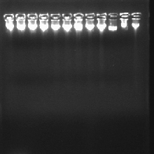
Figure 3.1: Genomic DNA from blood of the study participants
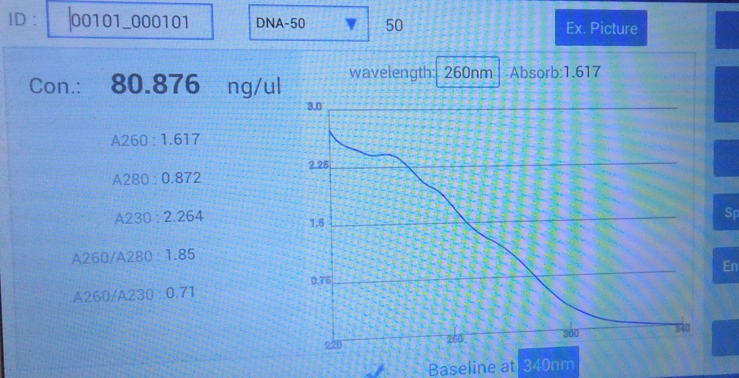
Figure 2: Genomic DNA isolated from blood of T2DM patients and healthy controls (A).

